Jertrude Dimaano INM 420 SAA

AI in Web Dev : Process Description

1. Which AI tools did you use? For this assignment, I ended up using three AI tools:
- ChatGPT — I used this to initially convert the User Persona image into HTML/CSS code.
- Claude (Anthropic) — I used this to help debug and tweak the code so it would more closely match the original design.
2. What prompts did you use to tweak the code? These are some of the prompts I used to refine the code:
- "Change the accent color to match the original design."
- "Fix the section headings color using the gold variable."
- "Change the font for Sarah's name to Inter Black."
- "Change the quote below Sarah's name to Inter italic."
3. What percentage of code did you fix or update by hand? I'd say around 30% of the code was manually fixed or updated. Some of the things I had to do myself included swapping in the correct photo of Sarah, fixing a missing quote in the font-family property, adjusting some of the color variables directly in the CSS, and recovering my AiWeb_Assignment folder on GitHub after I accidentally deleted it.
4. Was it worth using AI as a first step? Honestly, yes it was worth it. AI saved me a lot of time by generating the base structure and layout right away. That said, the output wasn't perfect and I still had to go in and fix things manually, especially with the fonts, colors, and the image.
Looking back, I think giving the AI more specific instructions from the start like the exact fonts, hex codes, and layout details would have gotten me a better result and less fixing to do afterward. But overall, using AI as a starting point was helpful, as long as you're ready to review and clean things up yourself.

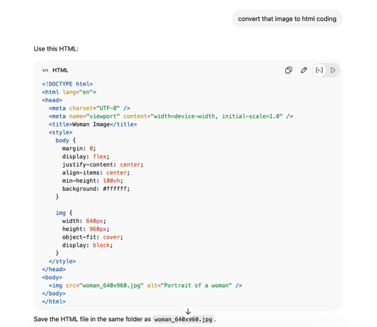
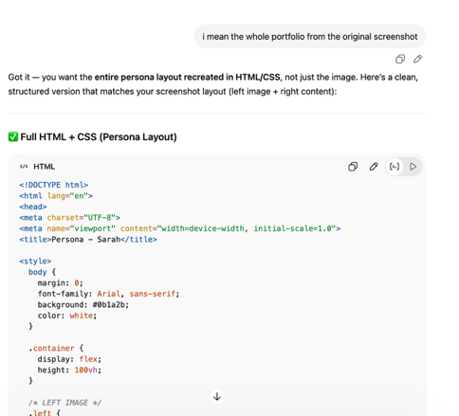

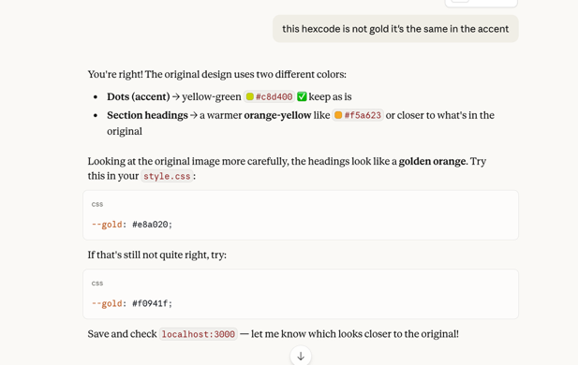

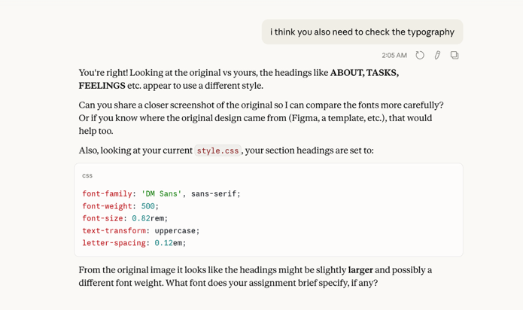
The output of the image from the original prompt from AI
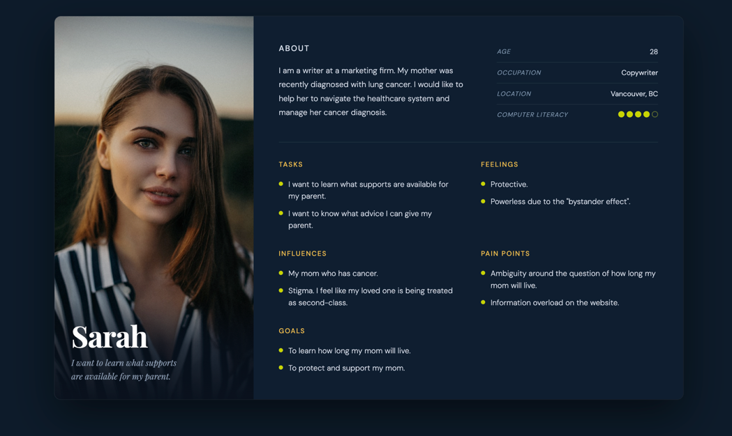
Final out with manual tweaks

